**FILE – FILE**

**https://app.workato.com/recipes/47968322-fle-file#recipe**

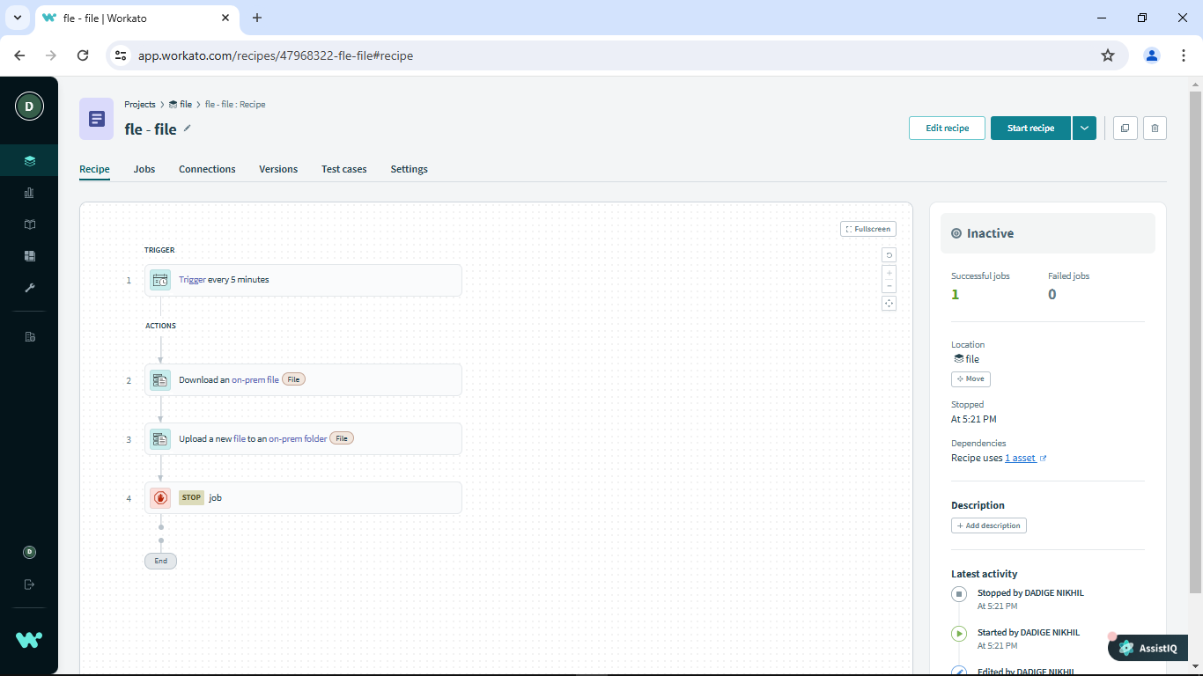

**FTP – FTP**

**https://app.workato.com/recipes/48000279-ftp-ftp#recipe**

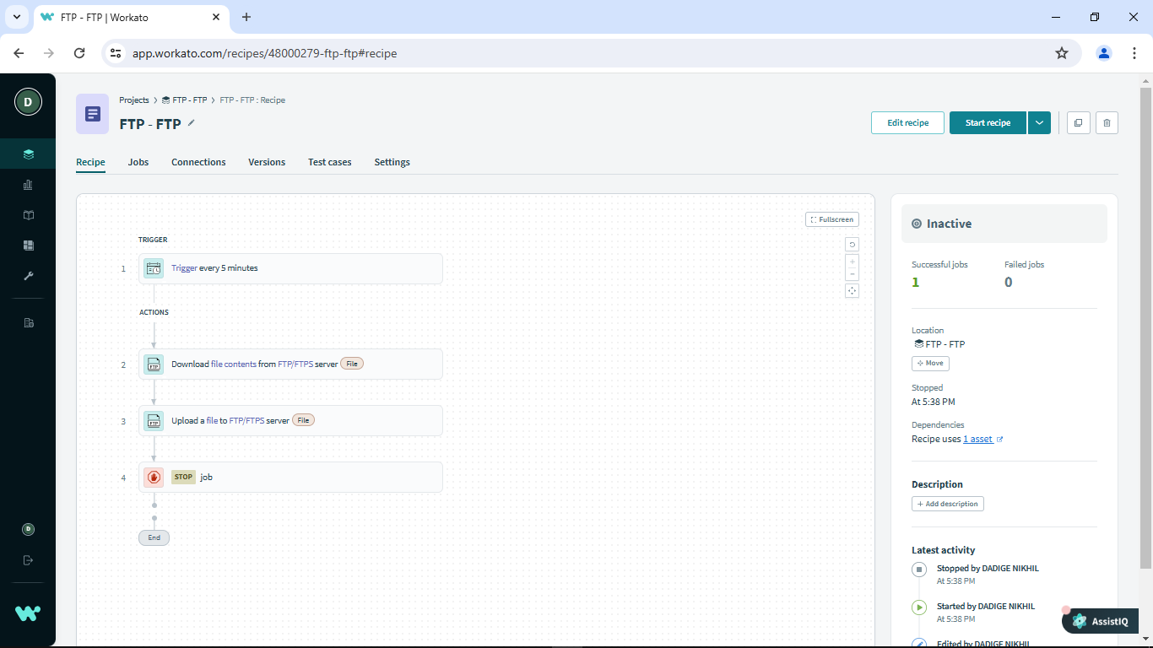

**FILE – FTP**

**https://app.workato.com/recipes/48002352-file-ftp#recipe**

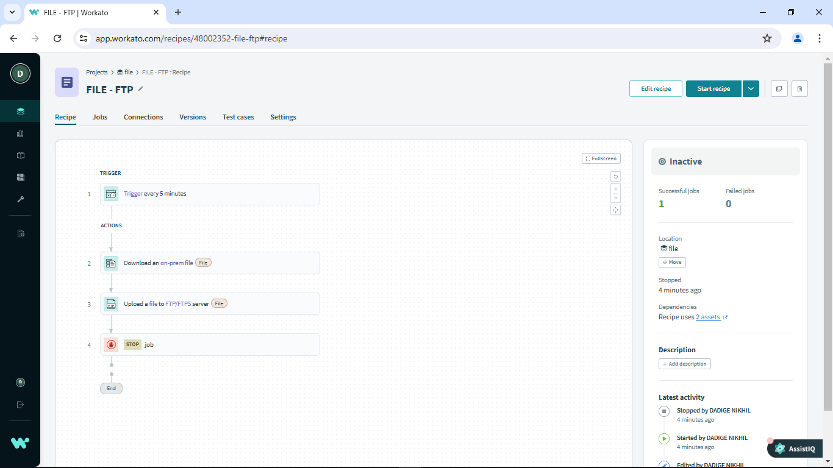

**FTP-FILE**

**https://app.workato.com/recipes/48002359-ftp-file#recipe**

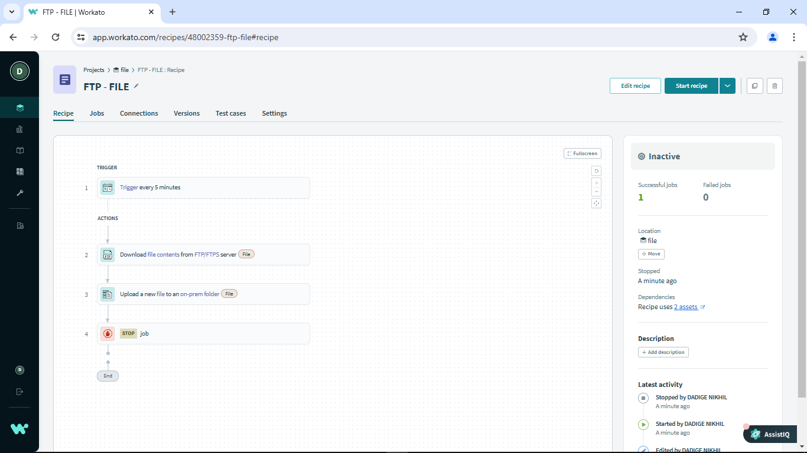

**ACTIVEMQ – FTP**

**https://app.workato.com/recipes/47964725-activemq-to-ftp#recipe**

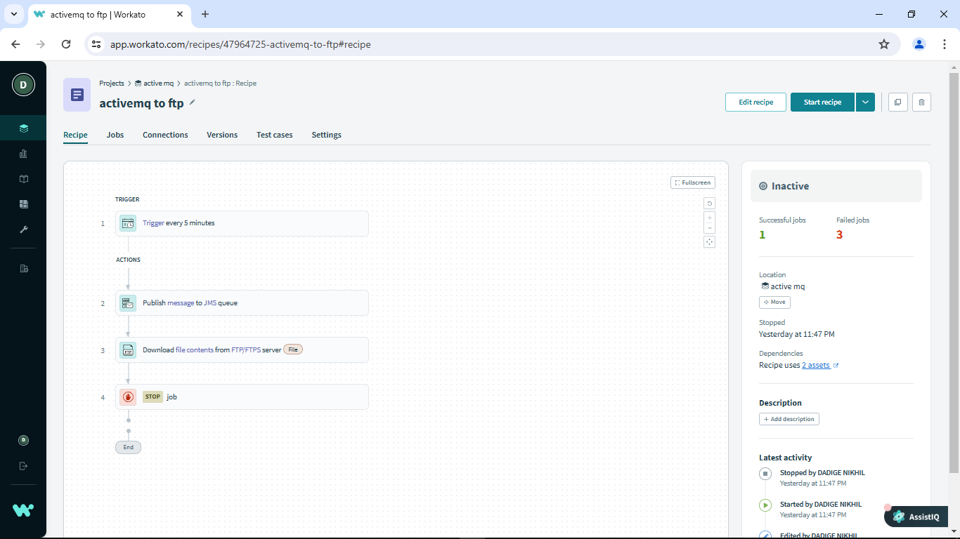

**FTP – ACTIVEMQ**

**https://app.workato.com/recipes/47964960-ftp-activemq#recipe**

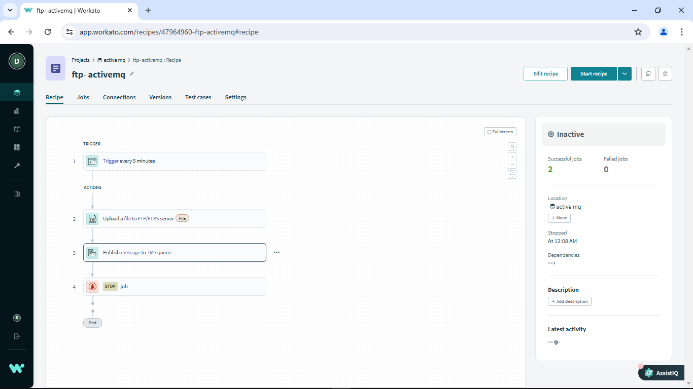

**ACTIVEMQ – FILE**

**https://app.workato.com/recipes/47965562-active-to-file#recipe**

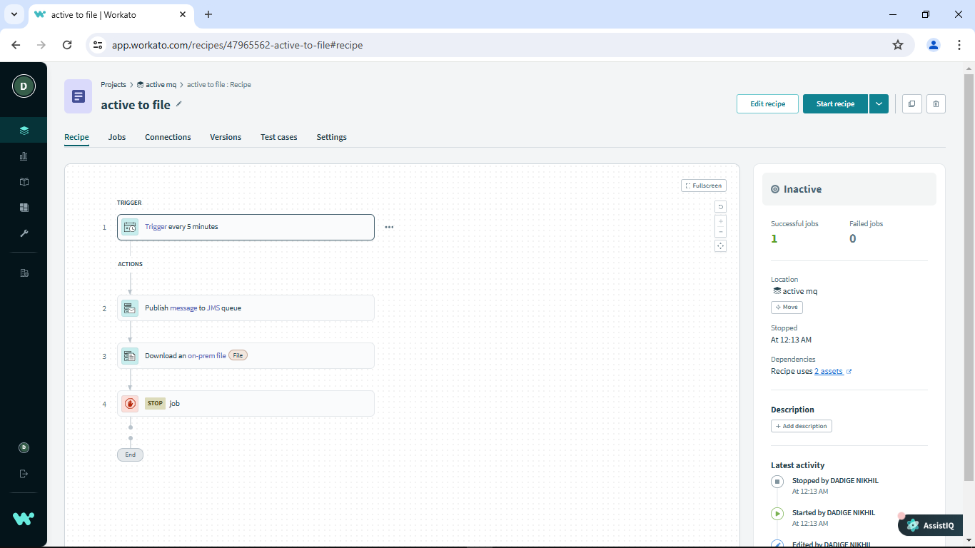

**FILE – ACTIVEMQ**

**https://app.workato.com/recipes/47965553-file-to-active-mq#recipe**

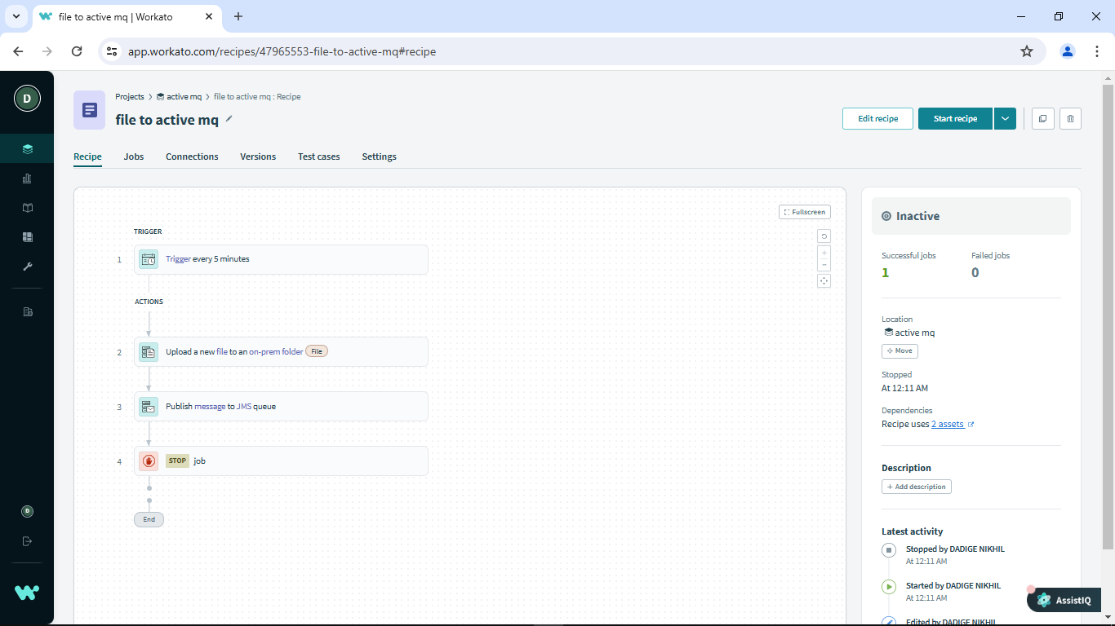

**MAIL – ACTIVEMQ**

**https://app.workato.com/recipes/47964295-email-toactive-mq#recipe**

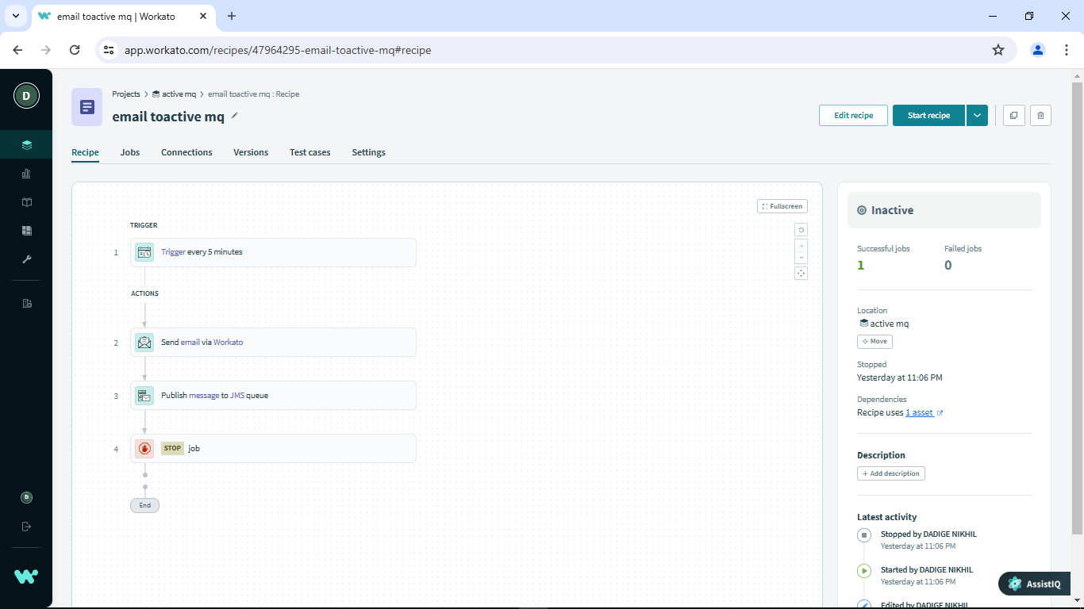

**ACTIVEMQ – MAIL**

**https://app.workato.com/recipes/47964495-activemq-email#recipe**

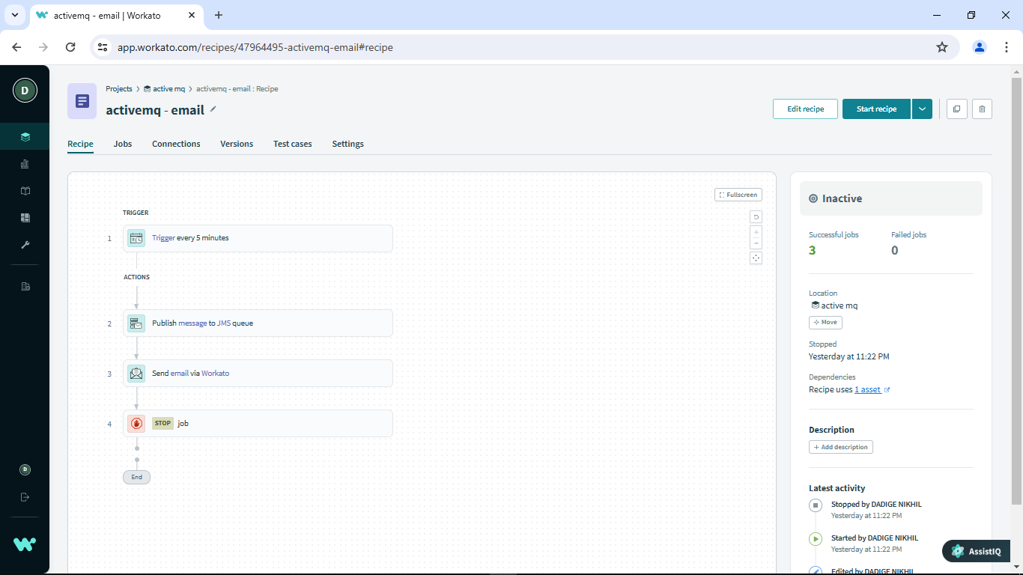

**FILE – MAIL**

https://app.workato.com/recipes/47962121-file-mail#recipe

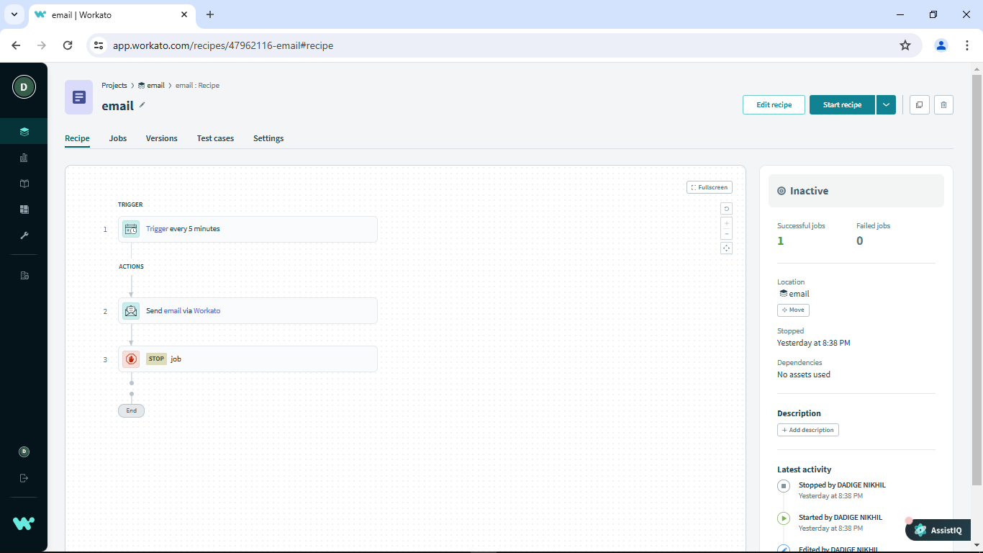

**EMAIL**

**https://app.workato.com/recipes/47962116-email#recipe**

